Michael Skeats
Testing Document

Test Case Table
Test ID  Num | Description | Test Data | Expected Result | Actual Result | Status  (pass/fail)
TC-1 | Add valid animal | Name=Leonard  Age=5  Color=brown  Weight=190  Type= lion  Mane size= 20 | Lion will be added to list | 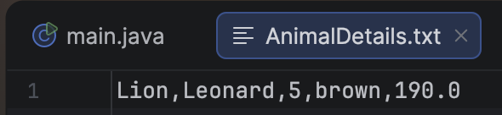  Lion successfully added to animal details | pass
TC-2 | Add animal without name value | Name =””  Age =5  Color= white  Weight = 123  Type= dove  Wingspan= 23 | Dove will not be added to list | 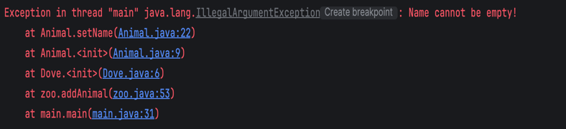  Illegal argument exception thrown, stopping submission. | pass
TC-3 | Add animal with a negative age value | Age= -1 | Error will occur | Exception thrown | pass
TC-4 | Remove animal | Name= leonard | Animal will Be removed | 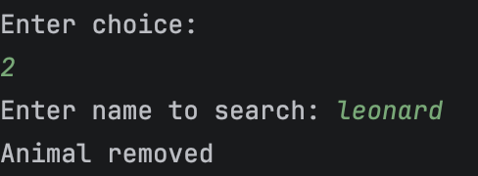  Animal successfully removed | pass
TC-5 | Remove animal that doesn’t exist | Name= Michael | Program will not be able to find requested animal | 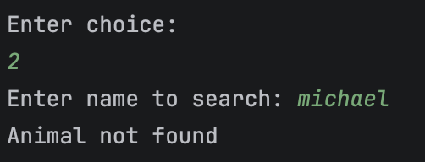 | pass
TC-6 | Show 2 animals | Choice= 4 | Name of animal will be displayed |  | pass
TC-7 | Show animals while no animals are in the zoo | Choice 4 | No animals will be displayed | 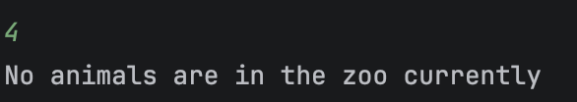 | pass
TC-8 | Attempt to modify animal that doesn’t exist | Choice =3 | No animal will be modified | 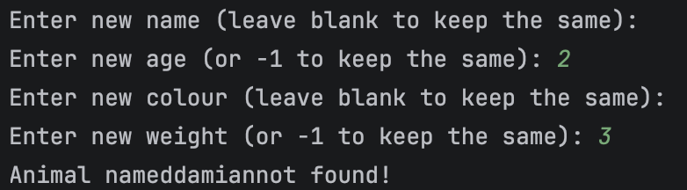 | pass
TC-9 | Attempt to modify an existing animal | New name= Daniel  New colour = white | Animal will be modified | 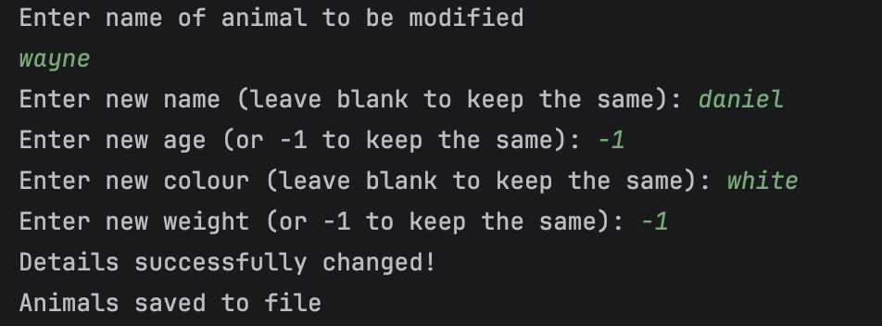 | pass
TC-10 | Searching for an animal that doesn’t exist | Name= Wilhelm  Choice= 5 | No animal will be found | 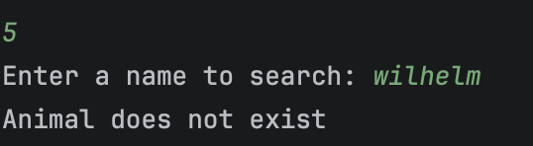 | pass
TC-11 | Searching for an animal that does exist | Name kaiser  Choice= 5 | Animal will be found and make sound will run | 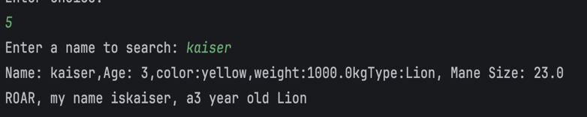 | pass
TC-12 | Attempting to do daily care when no animals exist | Choice =6 | Error message will show | 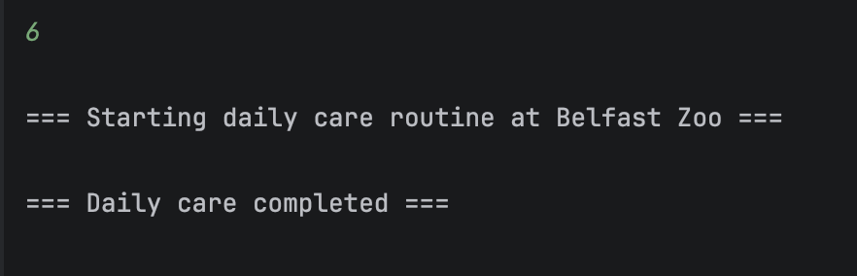  No error message was shown | fail
TC-13 | Daily care for lion | Choice =6  Type = lion | Only basic details will appear since lion doesn’t have an interface | 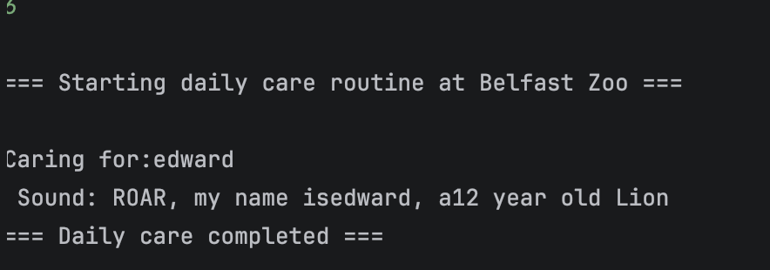 | pass
TC-14 | Daily care for dove | Choice = 6  Type= dove | Interface specific methods will run alongside basic methods | 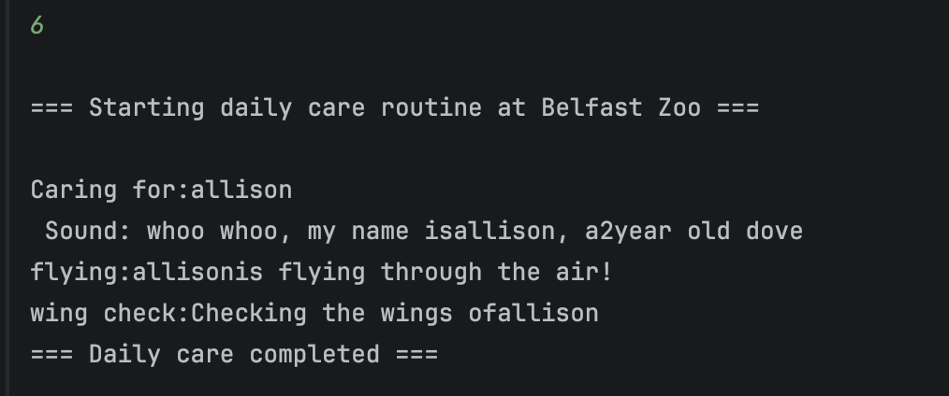 | pass
TC-15 | Daily care for Goose | Choice= 6  Type= Goose | Interface specific methods will run alongside basic methods | 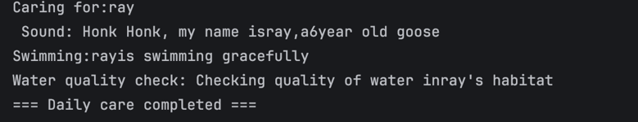 | pass
TC-16 | Report with 2 animals in the zoo | Choice =7 | Number of animals, type of animal and dominant colour will be printed | 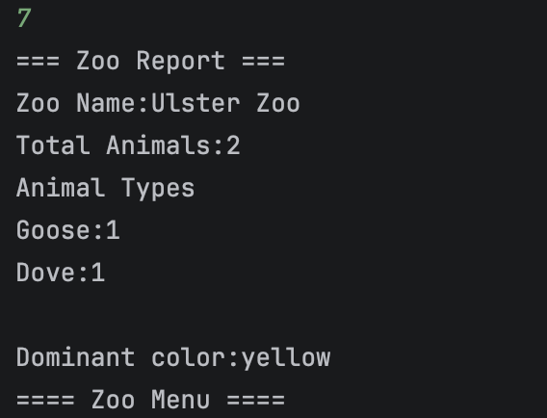 | pass
TC-17 | Save animals to file | Choice=9 | Animals will be saved to file Animal Details | 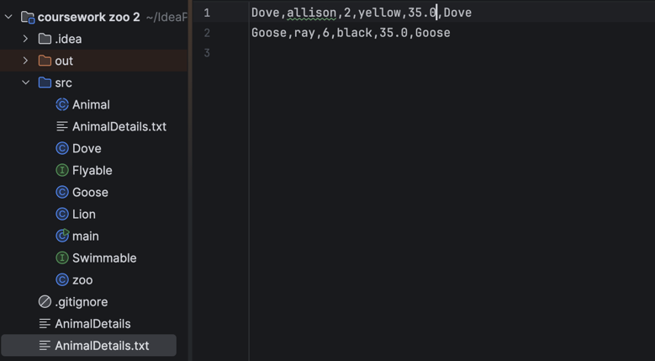 | pass
TC-18 | Load animals from file | Choice=8 | Animals previously saved will be loaded from file | 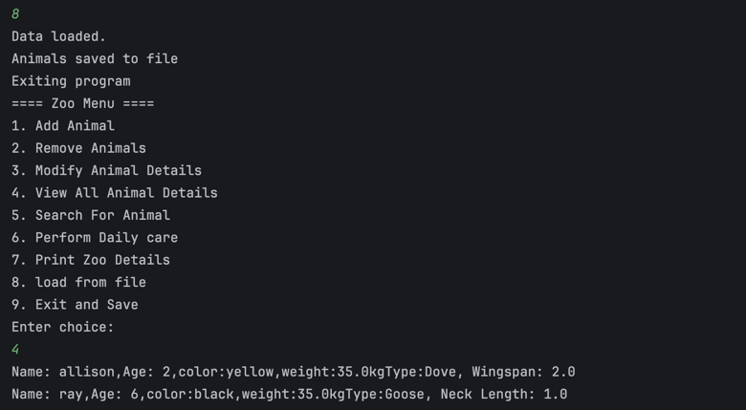 | pass

Requirement table
Requirement | Implemented (Yes/No) | Test case ID
Add Animal | yes | TC 1-3
Remove Animal | yes | TC 4-5
View Animal | yes | TC 6-7
Modify Animal | yes | TC 8-9
Search | yes | TC 10-11
Daily care | yes | TC 12-15
Report | yes | TC-16
Save | Yes | TC-17
load | yes | TC-18

Unit testing
Unit Test ID | purpose | Test Data | Expected result | Actual result | Status
UT-1 | Tests if overridden make sound class makes correct noise | Name=Leo  Age=5  Colour=golden  Weight=190  Mane size=25 | The expected result Is the same as the actual result. | 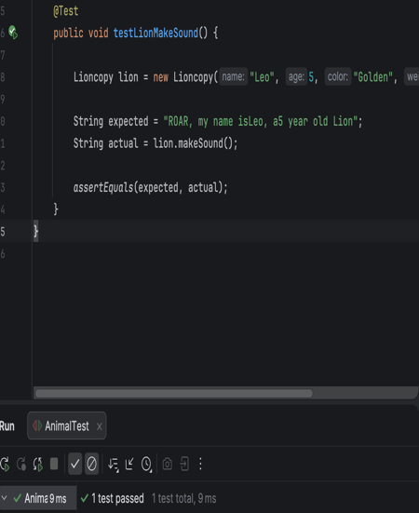 | passed
UT-2 | Tests if the get type method gets the correct animal | Name=Leo  Age=5  Colour=golden  Weight=190  Mane size=25 | The get type method gets the correct animal type when a lion in inputted | 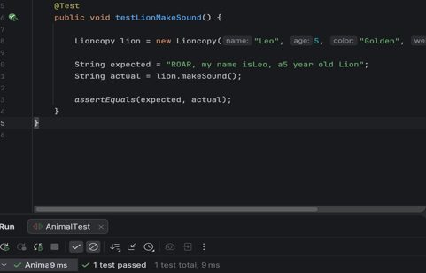 | passed
UT-3 | Tests if set age method rejects a negative value | Set age= -3  Expected age = 5 | Get age rejects the negative value and throws an illegal argument exception | 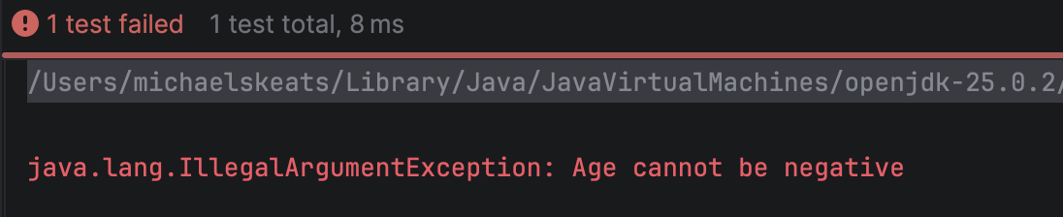 | passed

